Message Façade

An Enterprise Java Bean client wants to invoke the methods of multiple EJBs within the context of one use case, and doesn’t require an immediate response from the server.
How can an EJB client invoke the methods of multiple session or entity beans within one transaction, without the need to block and wait for responses from each bean?
* * *
Consider a simple web-based airline registration system where a servlet receives a request to reserve a seat for a user for a particular flight. In this scenario, a servlet must register a user with an airline, determine if seats are available on a flight and if so, reserve a seat for a user, as in figure X.X.
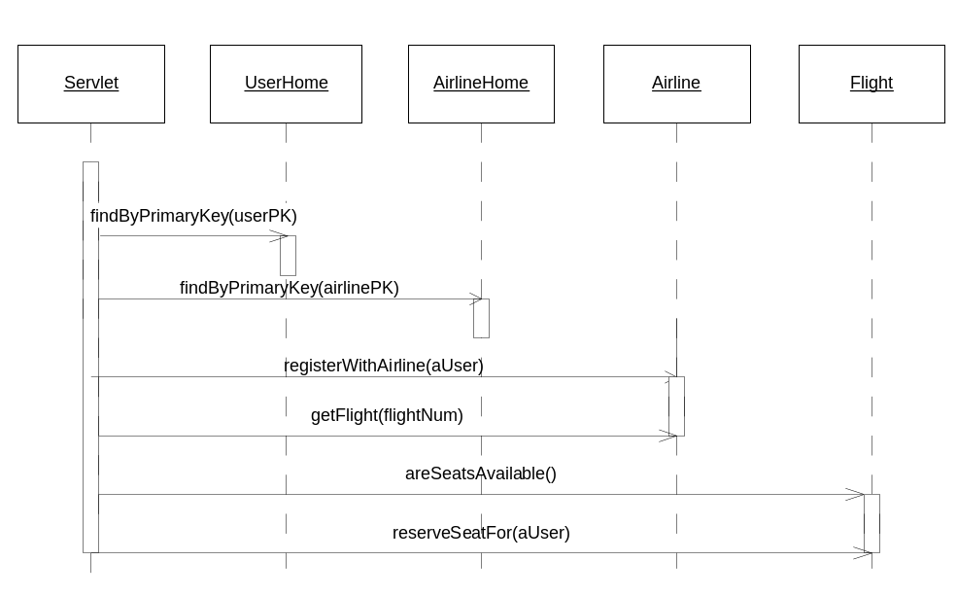
Figure x.x Reserve Seat Usecase

The execution of this use case suffers several drawbacks:
Poor performance. If the servlet client is calling the entity beans via remote interface (as opposed to the EJB 2.0 local interface), this use case will perform poorly, as the whole process requires 6 network calls, as well as overhead of security/transaction management on part of the application server.
Unacceptable Response Time. A user interacting with a website will not stick around for longer than a couple of seconds. The execution of this use case requires a lot of background processing that could span multiple databases on different systems, because each entity bean call is a ‘synchronous’ call, the client would have to block until the entire process has been completed.
Unreliable / not fault tolerant. This use case could potentially call 3 separate EJB Server instances and 3 separate databases (one for users, one for airlines, one for flights). If any one of those servers were down, the entire process would fail, and the users reservation request would be lost. Even if the servlet layer were communicating with only one EJB server, the process would fail if the server was down.
Lack of transaction consistency. Since entity beans are transactional creatures, each method call on an entity bean will require separate transaction on the server side. This means that the execution of this use case could leave an inconsistent state in the database – if the ‘reserveSeat’ transaction fails, previous transactions (such as registering a user with an airline) would have already been committed, and that data meaning users would have been registered with the airline without flight bookings. The problem here is that when calling an entity beans methods directly, each method call is a separate unit of work, and a separate transaction.
High coupling. Our client writes directly to an entity bean API, which tightly couples the client with three separate entity beans. If the entity bean layer needs changing in the future, then we must also change the client.
Poor reusability. The business logic that executed the “reserve seat” use-case was embedded directly in the client. It therefore effectively becomes trapped in that client. Other types of clients (java applications, applets, other servlets, etc.) cannot reuse this business logic. This mixing of presentation logic with business logic is a poor application design for any serious deployment.
Poor separation of development roles. A common practice on large-scale projects is to separate the development tasks of presentation logic programmers (such as servlet/jsp developers) from the business logic/middleware programmers (EJB developers). By coding business logic in the client/presentation layer, a clear separation roles is not possible. Business logic and presentation logic programmers will step on each other’s toes programming in the presentation layer.
One solution is for our client to demarcate an aggregate, large transaction via the Java Transaction API (JTA). This would make each entity bean method call operate under the same transaction, in an all or nothing fashion. If the reservation fails, the airline registration will be rolled back. This approach only solves the transaction consistency problem, all the other problems with the old approach are still valid. Client-side transactions also contributes to poor maintainability. Usage of the Java Transaction API causes middleware logic for performing transactions to be interlaced with application logic. It is much cleaner to separate the two via declarative transactions, so that we can tweak and tune our middleware without affecting our business rules.
The most common solution is to use the Session Façade pattern. With this pattern, an application creates a layer of session beans that contain business logic to fulfill business use-cases. Each session bean performs bulk operations on entity beans or other server side resources on behalf of the clients, in one bulk call, as in Figure X.X in the Session Façade chapter.
Using Session Façade solves the problems of coupling, performance, maintainability, reusability and consistency, but does not completely solve the problems of response time and reliability. The client still has to block while complex and time-consuming reservation use case runs. The use case will also fail if the EJB server or any systems it relies on are not running at the time the use case was executed.
The takeaway point from our discussion is that we need a fault tolerant server-side abstraction that serves as an intermediary, executing use cases in one call and one transaction, sheltering clients from the complexities of the server side object model, which doesn’t require a client to block and wait for the use case to complete. Message Driven Beans are designed just for this.
Therefore,
Use Message Driven Beans to create a fault tolerant, asynchronous façade. Each message driven bean should contain bulk application logic to fulfill business use-cases. Clients should have access to message driven beans only, not entity beans.
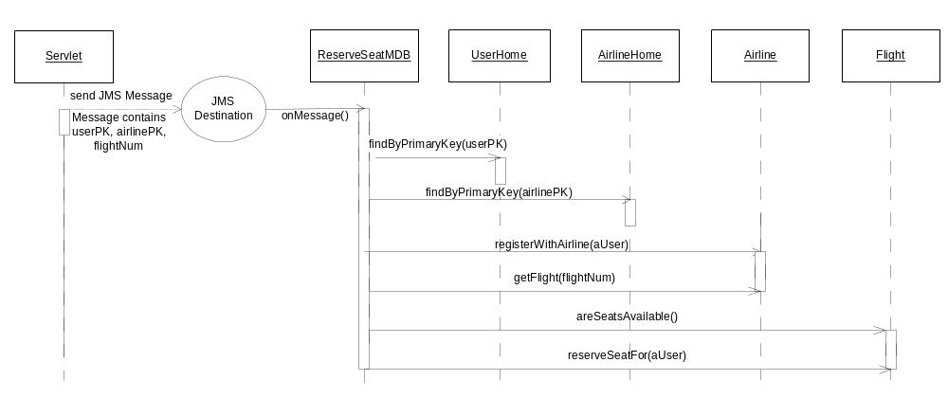To illustrate how this paradigm works, and the benefits of this paradigm, let’s take our previous example. Our business logic for reserving a seat on a flight will now be placed in the onMessage() method on a ReserveSeat message driven bean. The purpose of this MDB is to encapsulate all business/workflow logic related to reserving a seat on a flight, and to execute asynchronously, as in figure X.X.
Figure X.X Reserve Seat use case through a Message Façade

Here we have a servlet client creating a JMS message and passing in the necessary parameters. The servlet constructs a message containing all the parameters required (user’s primary key, flight number, airline primary key) and sends this message to a JMS destination created for the Reserve Seat use case. Upon receiving the message at the appropriate destination, the client will be free to continue (display the next web page). At this point, the message driven bean container will attempt to pass the message to the next available ReserveSeat message driven bean. If all ReserveSeat MDB’s in the pool are being used at the time of message reception, the JMS server should wait until the next one becomes available. Had this use case been executed through a session façade, a fully used session bean pool would have been a single point of failure and the client would have to manually retry.
Once a MDB becomes available, the container will execute the onMessage() method. At this point, the ReserveSeat message driven bean will linearly go through the process of executing the use case: register the user with the airline, check if seats are available and reserve a seat. While this time consuming process is occurring, the end user is free to surf around the site and go about their business.
One important advantage the message façade pattern has over the Session Façade is that asychrononously executed usecases can be guaranteed. That is, if the transaction fails at any point (perhaps the airlines’s systems go down or some other system failure occurs), the transaction will be rolled back and the JMS message put back on the queue. The transaction will then be retried later, without the knowledge of the client.
This behind the scenes behaviour also presents a problem. How is the client to be notified if the use case fails or succeeds? For example, if a seat cannot be reserved because the plain is fully booked, the client needs to be notified. In a synchronous model (using a session façade), the client would know immediately. In the asynchronous model, the client is no longer waiting to see if the use case succeeded, and needs to be alerted in some application specific form. The most common solution is email. If the use case succeeds/fails then the user will be emailed notification. Some companies might implement a system in such a way that a human would make a physical phone call, etc. If the application requirements allow it, some applications could use a polling model. That is, an end user will be assigned a particular place they can go to check the status of their request, similar to a tracking number used by modern courier services.
The takeaway point here is that when using the Message Façade pattern, developers must devise novel ways to communicate the results of a use case to the client.

The advantages to this paradigm are:
Instant response time / asynchronous communication. When a client sends a JMS message, it is free to continue processing without waiting for the server to complete the use case and respond. A long running, complex use case can thus be initiated, while control flow instantly returns to the user.
Low network overhead. Although applying a MDB layer will create a new MDB for every use case, the client can execute those use cases by sending one JMS message in one network call, as opposed to the previous six network calls. The benefits far outweigh the drawbacks.
Eliminates a single point of failure. Using messaging will ensure your application continues functioning even if the ejb server or some other subsystem it relies upon is down. For example, if the database is down, the MDBs transaction will not complete, and the reserve seat message will remain on the queue and retried later. If the EJB container is down, the message will again be stored. Such fail-over capabilities would not be possible if using a synchronous model.
High concurrency. Our message driven bean encapsulates all logic to perform the seat reservation. The session bean thus acts as a transactional façade, which localizes transactions to the server-side, and keeps them short.
Low coupling. The message driven bean buffers requests between the client and entity beans. If the entity bean layer needs changing in the future, we may be able to avoid changing the client because of the message driven bean layer of indirection.
Good reusability. Our seat reservation logic is encapsulated into a message driven bean, which can be accessed by any type of client (JSPs, servlets, applications, or applets). The encapsulation of business logic into message driven beans also means that our entity bean layer is also reusable across message driven or session beans, even different applications.
Good maintainability. Transactions can be defined declaratively in the ReserveSeat beans deployment descriptor, rather than programmatically via the JTA. This gives us a clean separation of middleware and application logic, which increases maintainability and reduces the likelihood of errors.
A clean verb-noun separation. The message driven bean layer models the asynchronous, application specific use cases: the verbs in our application, while the entity bean layer models the business objects: the “nouns” in our application. This architecture makes it very easy to map usecases from a requirements document to a real EJB architecture.
Good separation of development roles. Presentation logic programmers and business logic programmers can work completely independently. Business logic programmers supply the JMS destination name and the required ‘contents’ of the message. Presentation layer programmers simply work against this contract.
However, as a by-product of using Message Driven Bean, the Message Façade Pattern also has some drawbacks:
Message-driven beans have weakly-typed input parameters. The role of a message-driven bean is to consume JMS messages, all of which appear identical at compile time. This is in contrast to Session/Entity beans, who leverage java’s built in strong typing of the methods and parameters of the remote and local interfaces to catch common errors at compile time. Extra care must be taken by the developer to load a JMS message with the appropriate contents required by its destined MDB.
Message-driven beans do not have any return values. Since MDB invocations are asynchronous, Message Façade cannot be used for use cases which require a return value after execution. Using Message Façade is thus superficially similar to using Session Façade, where all session bean methods simply return void. However, it is possible to get a response from a message-driven bean back to the message creator using JMS as the transport mechanism, please refer to the book Mastering Enterprise Java Beans, Second Edition for a discussion of these mechanism.
Message-driven beans do not propagate exceptions back to clients. Unlike Session/Entity beans, Message driven beans cannot throw application exceptions or RemoteException from any of their methods. MDBs must therefore handle all the exceptions presented in some application specific format (ie: emailing the user if something went wrong, logging errors to an admin log, etc).

Message Façade is a very powerful pattern for building decoupled, highly scalable applications. A typical EJB system would likely use a combination of the Session Façade and Message Façade patterns. Session Façade is the clear choice for ‘read’ type operations, where a client requires some data from the server, or when a client needs to explicitly wait for a use case to complete. Message Façade is clear choice for update operations, where the client does not need to instantly see the results of the update. The scalability and fault tolerant benefits of the Message Façade pattern over the Session Façade pattern are significant. Developers should evaluate each use case in their designs carefully, asking themselves if the use case is of a synchronous or asynchronous nature. This will be decisive factor in choosing one pattern over the other.

